Making a Pinhole Sun Projector
by Chris Anderson
Centennial Observatory
College of Southern Idaho
Materials:
- One long, sturdy cardboard tube, open on both ends. The width of the tube doesn’t matter, but the longer it is, the better. Thin-walled tubes are easier to work with than thick-walled.
- One piece of heavy-duty aluminum foil, large enough to cover one end of the cardboard tube
- Three pieces of white paper or light cardstock
- Packing tape
- Non-shiny scotch tape
- (Optional) Black construction paper or flat black spray paint
Tools:
- One drafting compass
- One ruler
- One sharp craft knife
- Scissors
- One #16 beading needle
Introduction:
It is not safe to look directly at the sun! The sun’s ultraviolet and infrared light can cause permanent blindness, much like looking at a welding arc without welding glasses. During a partial solar eclipse (or during the partial phases of a total eclipse), the moon can block enough of the sun that it’s possible to look at it without discomfort. However, the sun’s invisible ultraviolet and infrared light will still damage your eyes, which won’t be detected until it’s too late. DON’T RISK YOUR PRECIOUS EYESIGHT! NO VIEW OF THE SUN IS WORTH IT!
This project provides a safe way to view a projected image of the sun during the partial phases of an eclipse, with no risk to your eyes.
Construction instructions:
- Making the pinhole:
  - Make a “sandwich” by laying a piece of aluminum foil large enough to cover one end of the cardboard tube between two sheets of paper.
  - Use the needle to poke a small hole through all three layers so that it passes through the middle of the foil. You need not push the needle all the way in—just enough to pierce the foil is good.
  - Remove the paper and put the aluminum foil over one end of the tube with the pinhole near the center of the tube (it doesn’t have to be perfectly centered). Carefully smooth the foil down over the sides of the tube and secure it with packing tape.
- Cutting the viewing port:
  - Measure the diameter of the tube. Spread the compass so that the point and pencil are 1/4th of the tube’s diameter apart. For example, if your tube is 8 cm in diameter, the compass should be spread 2 cm wide.
  - Stick the point of the compass one tube diameter from the end of the tube and draw a circle on the side of the tube. For example, if your tube is 8 cm in diameter, place the point of the compass 8 cm from the end of the tube. Take your time—drawing a circle on a curved surface is tricky!
  - Use the craft knife to carefully cut out the circle you drew with the compass. You might want to have someone hold the tube steady (with fingers far from the knife!) while you cut.
  - (Optional) Paint the inside of the tube flat black on the end nearest the viewing port to cut down on reflected light from the inside of the tube. This will improve the contrast of the projected solar image. Don’t worry about getting the paint very far into the tube—it only needs to be about as far in as the viewing port. Instead of painting, you can also cut a strip of black construction paper to fit inside the tube, and secure it with scotch tape (preferably, the kind that isn’t shiny) or craft glue.
- Making the projection screen:
  - Stand the tube on a piece of white paper with the viewing port end down. If you’re using the same paper you used in step 1 and 2, be sure to use the part of the paper without the pinhole in it. Trace around the tube with a pencil.
  - Cut out a circle from the paper which is wider than the circle you just traced. It doesn’t have to be a perfect circle; it just needs to be about 3 cm bigger than the traced circle all the way around.
  - Cut slits from the outer edge of the circle to the inner circle (traced from the tube), about 1 cm apart, all the way around the circle.
  - Cover the end of the tube nearest the viewing port with the paper circle. Fold the strips down flat against the side and secure them with packing tape. Don’t cover up the hole (the viewing port!) in the side of the tube!
- You’re done! Be careful not to touch the foil so you don’t tear it.
Using the pinhole projector:
- Take your projector outside on a day when the sun is shining (and hopefully, when there’s an eclipse going on!).
- Hold the tube with the viewing port end on the ground and the pinhole end pointing at the sun. The sun’s image will form on the projection screen when the tube’s shadow is as small as possible.
- Look at the projection screen inside the tube through the viewing port. You should see an image of the sun projected by the pinhole onto the paper. (If not, your tube must not be pointing directly at the sun. Move it until the sun image falls on the center of the white paper.)
- Longer tubes will project a larger, dimmer sun image. Shorter tubes will project a smaller, brighter sun image. The width of the sun image will be about 107 times smaller than the length of the tube (to understand why, see the “math” section, below). For example: A 48” (122 cm) long tube will produce an image that is 48” ÷ 107 = 0.45” (1.1 cm) wide. For a larger image, consider taping two tubes together, end-to-end, before starting the project. Just be sure to tape them together with opaque tape (e.g. duct tape) to prevent stray light from leaking in at the seam.
- If your tube is long and the image is dim, try to get as much of the lower end of the tube in shadow as possible, and avoid setting up near bright surfaces (like light-colored walls receiving direct sun). You can also try putting a blanket or towel over your head to block as much stray light coming in from the sides as possible. Just be sure sunlight can still shine on the pinhole in the aluminum foil!
Doing the math:
The sun’s average distance from Earth (D_{Sun}) is about 93,000,000 miles (150,000,000 km). The sun’s diameter (d_{Sun}) is about 865,000 miles (1,390,000 km). To calculate the diameter of a solar image (d_{Image}) projected at a distance D_{Image} from a pinhole, we will use the principle of similar triangles (see the figure below).
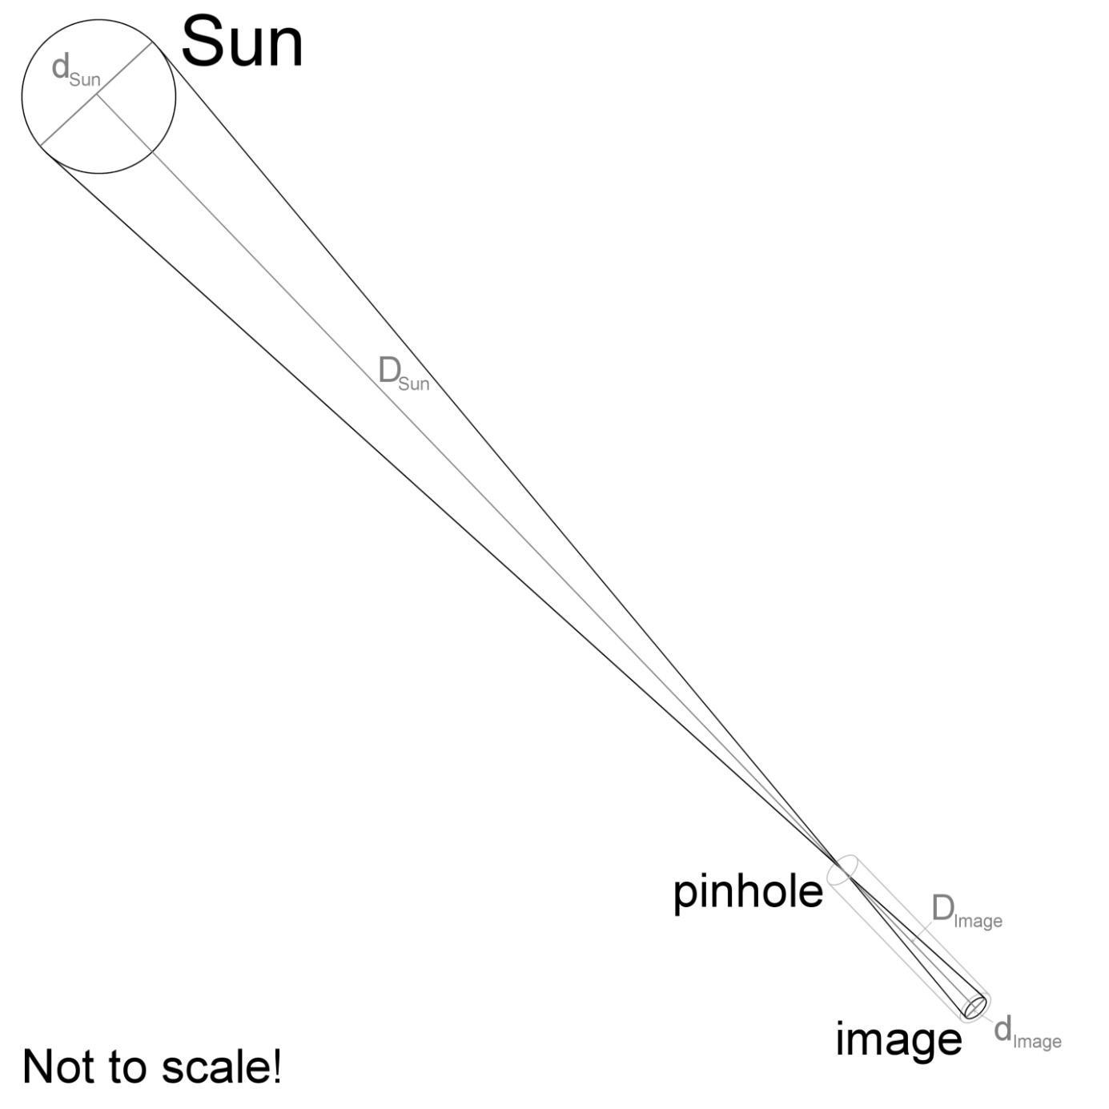
The triangle from the pinhole to the sun has the same proportions as the triangle from the pinhole to the image. So:
$$\frac{{\text{d}}_{\text{Image}}}{{\text{D}}_{\text{Image}}}\text{=}\frac{{\text{d}}_{\text{Sun}}}{{\text{D}}_{\text{Sun}}}$$ | (1)
To calculate the diameter of the image, we’ll solve equation (1) for d_{Image} by multiplying both sides by D_{Image}:
$${\text{D}}_{\text{Image}}×\frac{{\text{d}}_{\text{Image}}}{{\text{D}}_{\text{Image}}}\text{=}\frac{{\text{d}}_{\text{Sun}}}{{\text{D}}_{\text{Sun}}}×{\text{D}}_{\text{Image}}$$
Since D_{Image} appears in both the numerator and the denominator on the left side of the equation, it cancels out:
$${\text{D}}_{\text{Image}}×\frac{{\text{d}}_{\text{Image}}}{{\text{D}}_{\text{Image}}}\text{=}\frac{{\text{d}}_{\text{Sun}}}{{\text{D}}_{\text{Sun}}}×{\text{D}}_{\text{Image}}$$
leaving:
$${\text{d}}_{\text{Image}}\text{=}\frac{{\text{d}}_{\text{Sun}}}{{\text{D}}_{\text{Sun}}}×{\text{D}}_{\text{Image}}$$ | (2)
Astronomers have measured the sun’s diameter and average distance. Using these values we can find the size of the image compared to the length of the cardboard tube:
d_{Sun} = 1,392,530 km (865,374 miles)
D_{Sun} = 149,597,871 km (92,955,807 miles)
$${\text{d}}_{\text{Image}}\text{=}\frac{1,392,684 \text{km}}{149,597,871 \text{km}}×{\text{D}}_{\text{Image}}$$

$${\text{d}}_{\text{Image}}\text{=}0.009309518×{\text{D}}_{\text{Image}}$$
Note: Since kilometers appear in both the numerator and denominator, these units cancel, just as a number that appears in both the numerator and denominator would. Thus, the formula above will calculate the diameter of the image (d_{Image}) in the same units used to measure the length of the cardboard tube (D_{Image}).
Taking the reciprocal of 0.009309518 (that is: 1 ÷ 0.009309518 = 107.4170) tells us that the diameter of the image will be about 107 times smaller than the length of the cardboard tube:
$${\text{d}}_{\text{Image}}\text{=}\frac{1}{107}×{\text{D}}_{\text{Image}}$$ | (3)
Exercises:
- If your cardboard tube is 48” (122 cm) long, how wide of an image will it make?
- How long of a tube would you need to project an image 2 cm (0.78”) wide?
- How many times the sun’s diameter is the average distance to the sun (in other words, how many suns lined up in a row would fit between the earth and sun)?
- On August 21st, 2017, there was a solar eclipse visible across North America. On that day, the distance to the sun (D_{Sun}) was 151,318,246 km. Use this information to calculate a new version of equation (3) for August 21st, 2017.
- Use your more accurate version of equation (3) to calculate the width of the sun image (d_{image}) projected by a 48” (122 cm) cardboard tube on August 21st, 2017.
Answer key:
- Using equation (3):
d_{image} = D_{image}/107
d_{image} = 48”/107 = 0.449” (imperial units)
d_{image} = 122 cm/107 = 1.14 cm = 11.4 mm (metric units)
- Again, using equation (3), solved for D_{image}:
D_{image} = 107 x d_{image}
D_{image} = 107 x 0.78” = 83.5” (imperial units)
D_{image} = 107 x 2 cm = 214 cm = 2.14 m (metric units)
- Since d_{Sun} = 1,392,530 km (865,374 miles) and D_{Sun} = 149,597,871 km (92,955,807 miles), the sun’s average distance is D_{sun} / d_{sun} solar diameters:
D_{sun}/d_{sun} = 149,597,871 km/1,392,530 km = 107.4 (i.e. a little more than 107 suns would fit in the space between the earth and sun).
- The diameter of the sun (d_{sun}) doesn’t change, but the distance to the sun (D_{sun}) does, due to Earth’s elliptical (non-circular) orbit. If D_{sun} = 151,318,246 km, then the coefficient in equation (3) goes from 1/107 to d_{sun} / D_{sun} = 1,392,530 km/151,318,246 km = 1/108.6643 (nearly 1/109).
- Using our new equation (3):
d_{image} = 1/109 D_{image}
d_{image} = 1/109 (48”) = 0.440” (imperial units)
d_{image} = 1/109 (122 cm) = 1.12 cm = 11.2 mm (metric units)

